**CSE 306**

**TD 06**

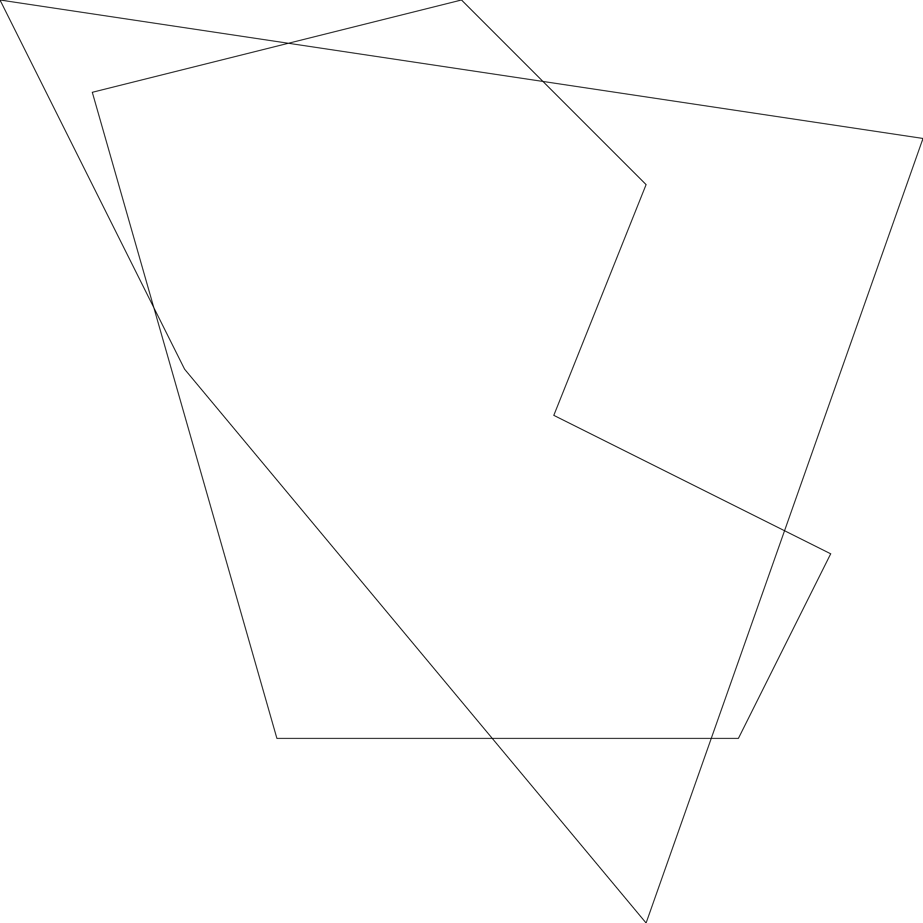

Two polygons before clipping

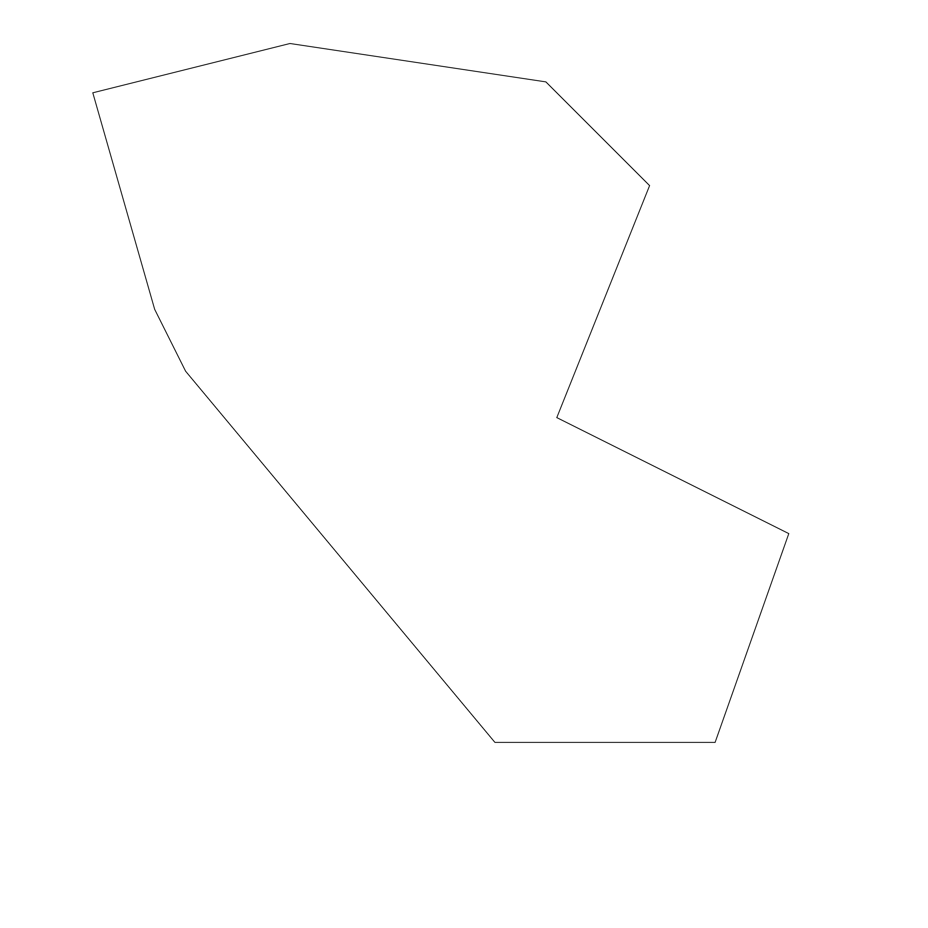

After clipping

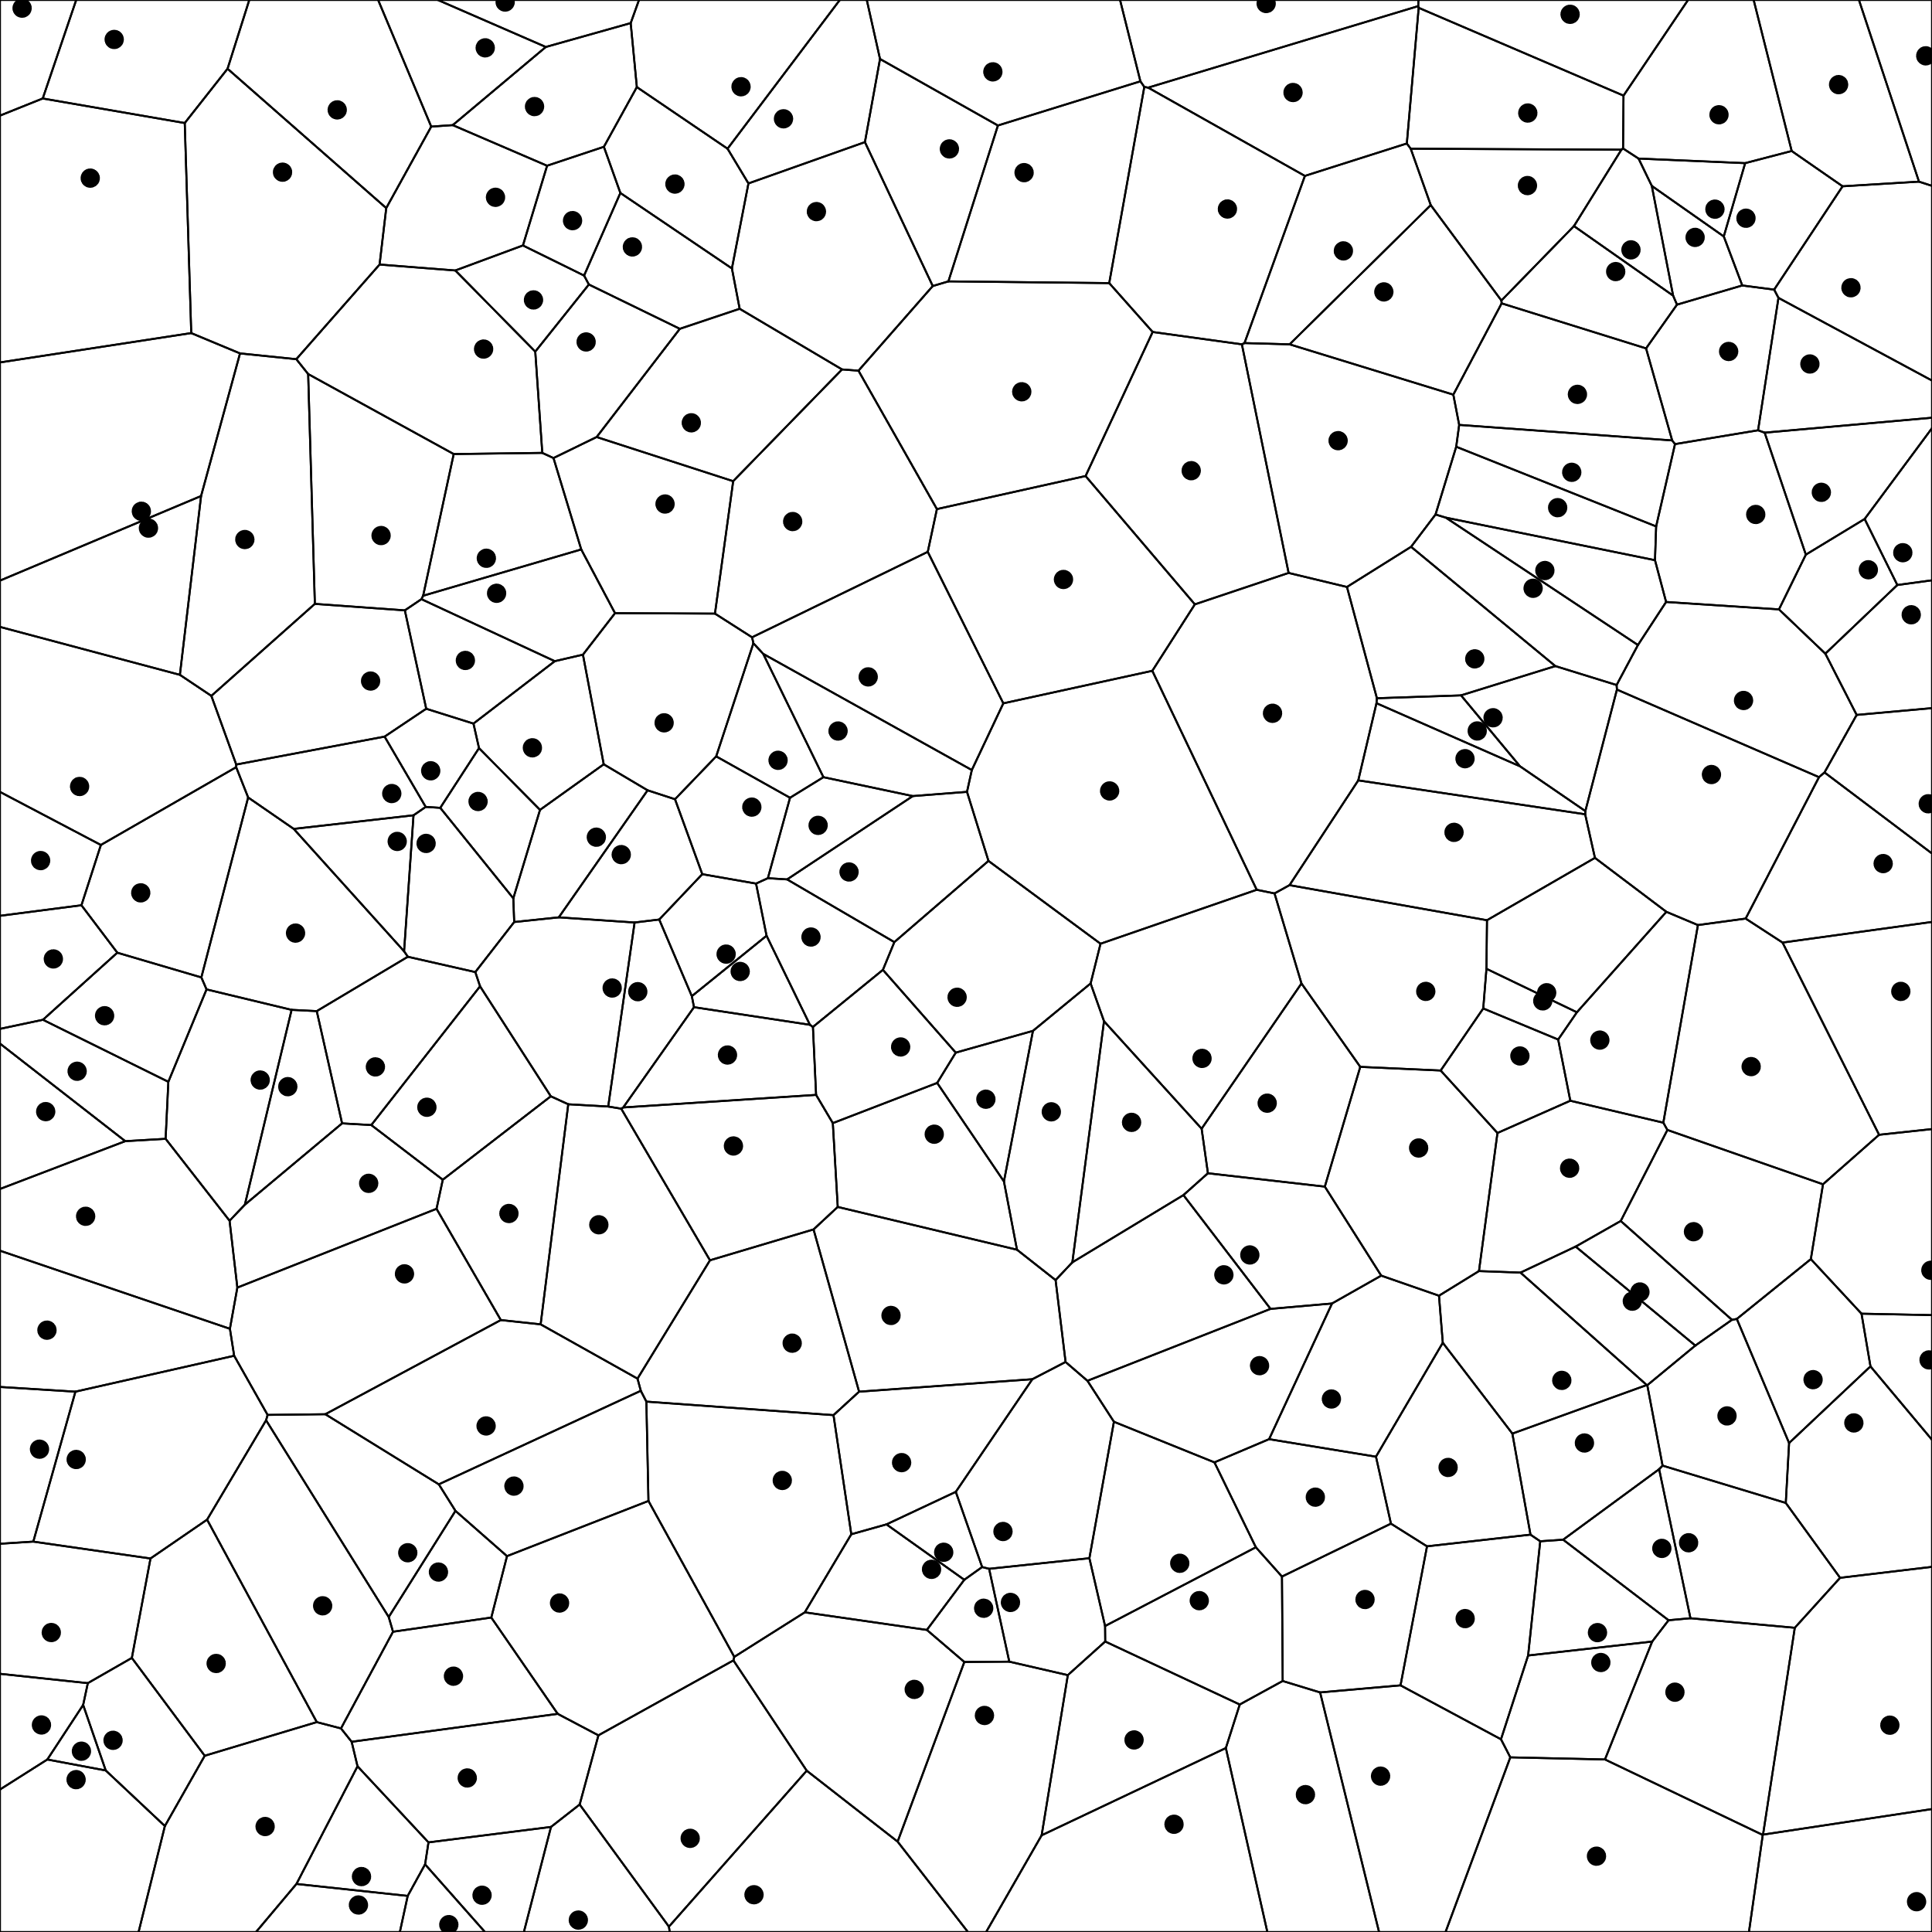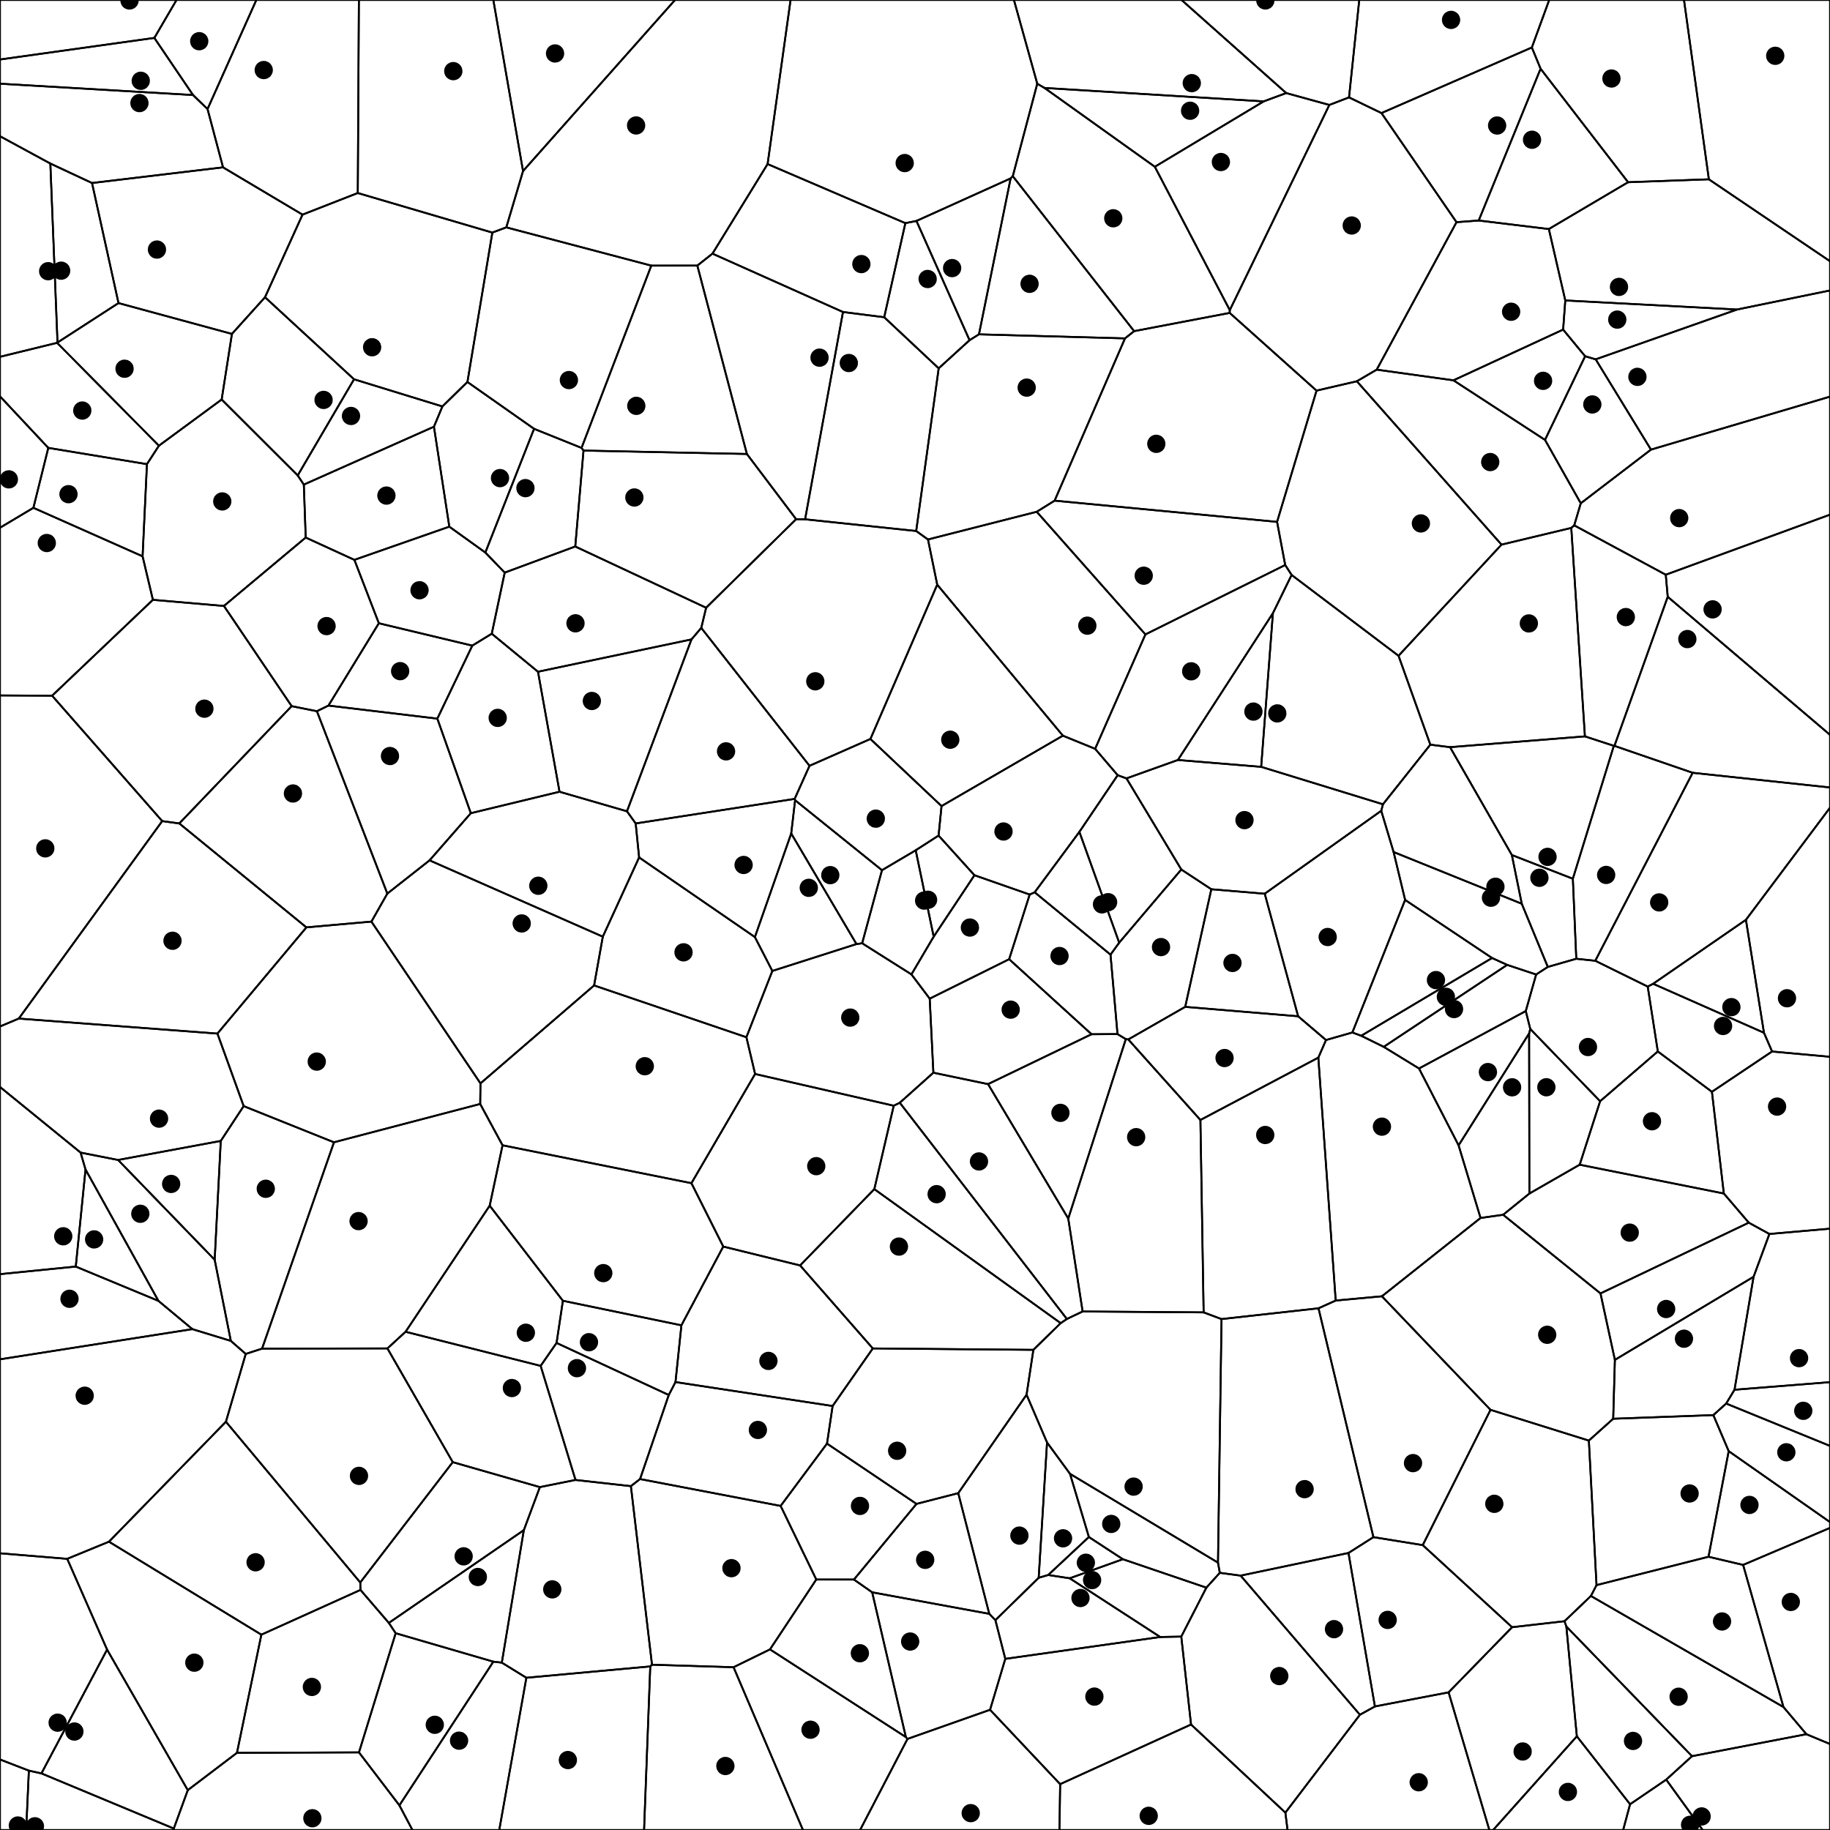

Voronoi diagram with 200 random points

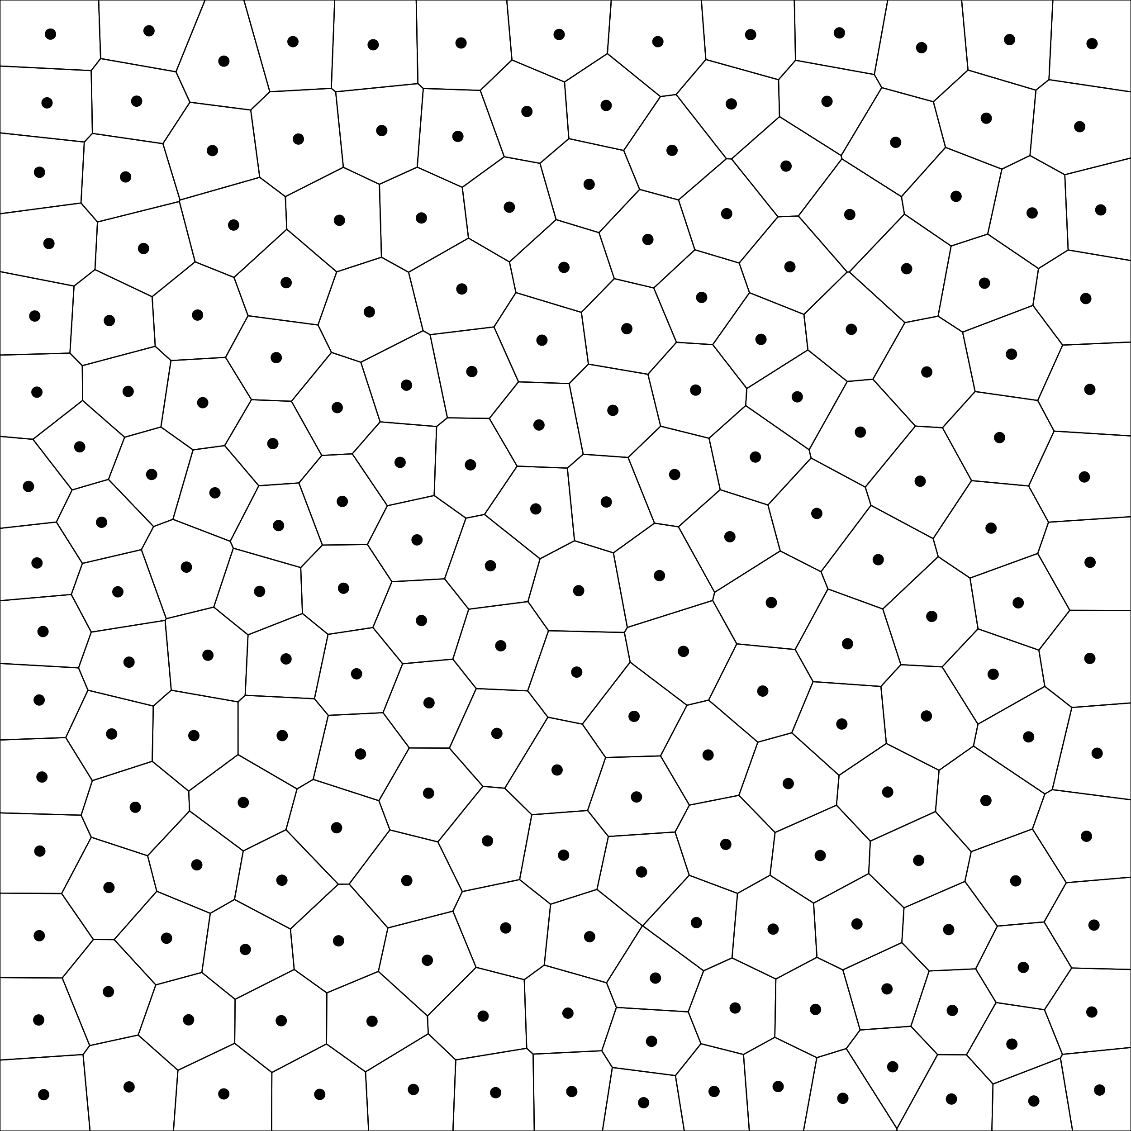

Centroidal Voronoi tessellation with 20 iterations

**TD 07**

Power diagrams with 200 pseudo random points

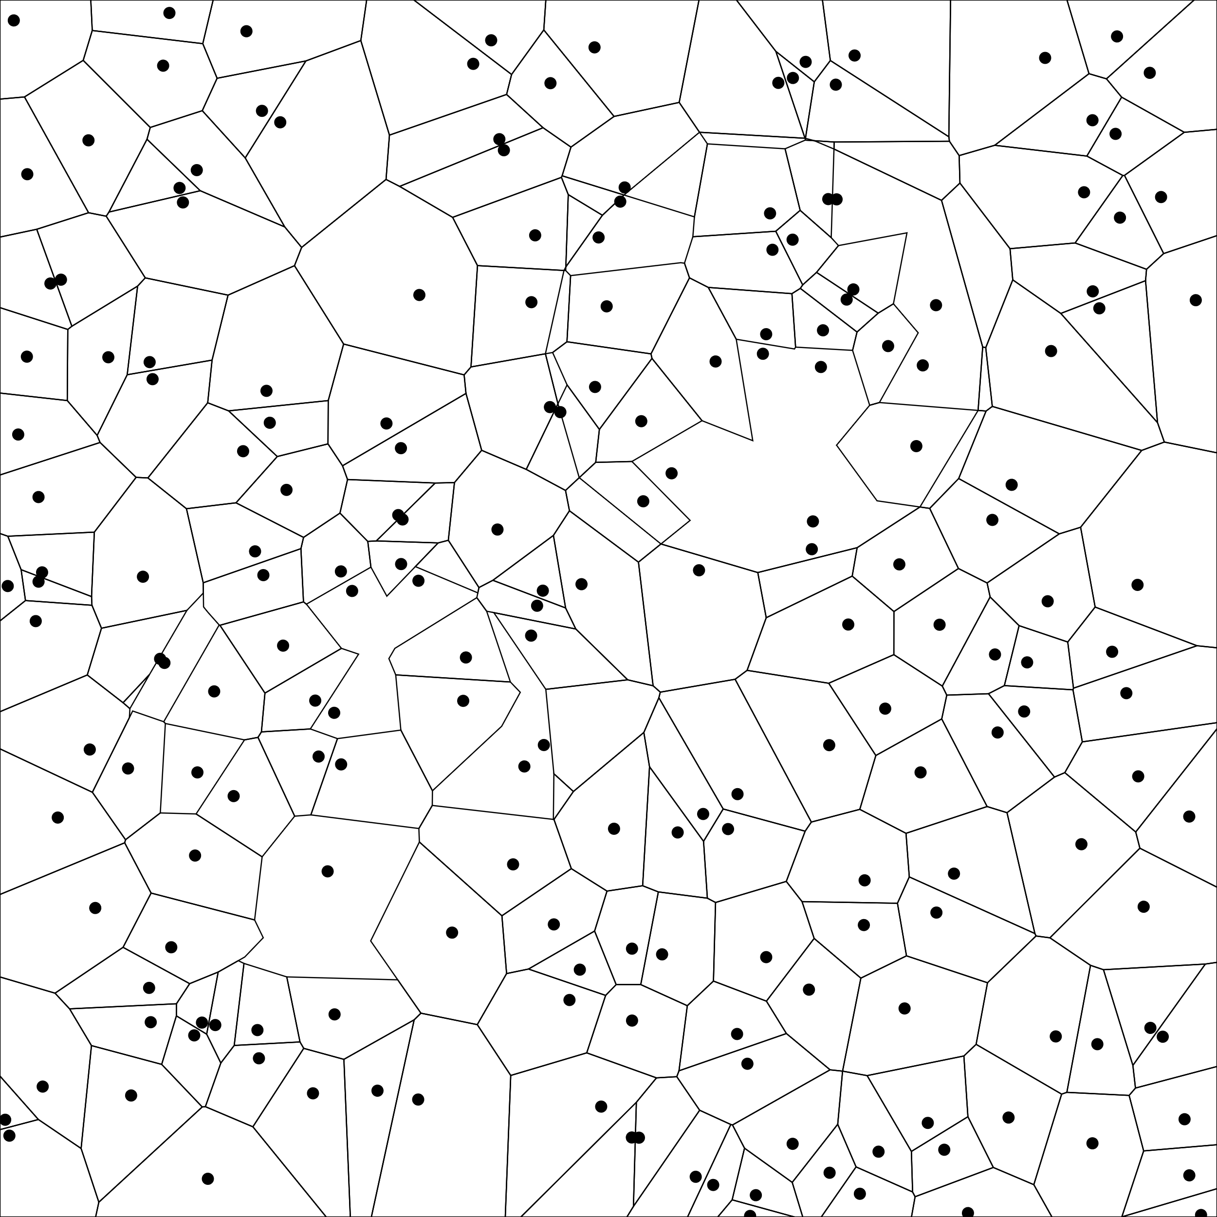

w_i = 0.2 and w_100 = 0.23 (all points have a weight of 0.2 except the 100th point that has a weight of 0.23)

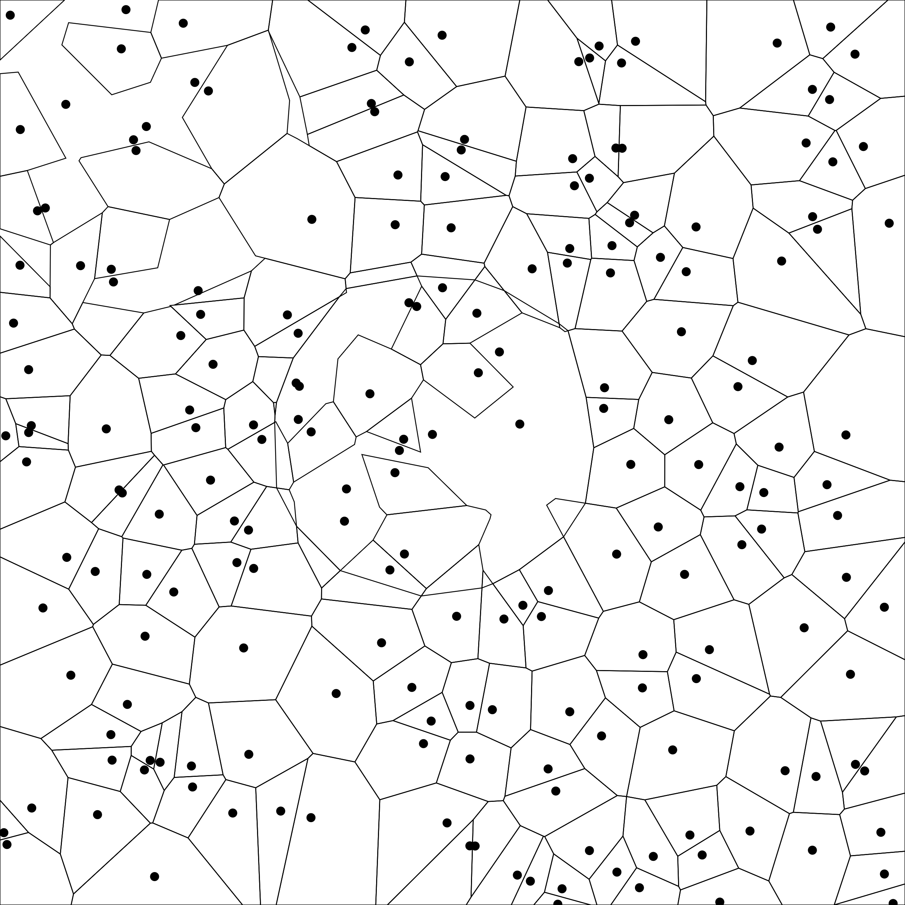 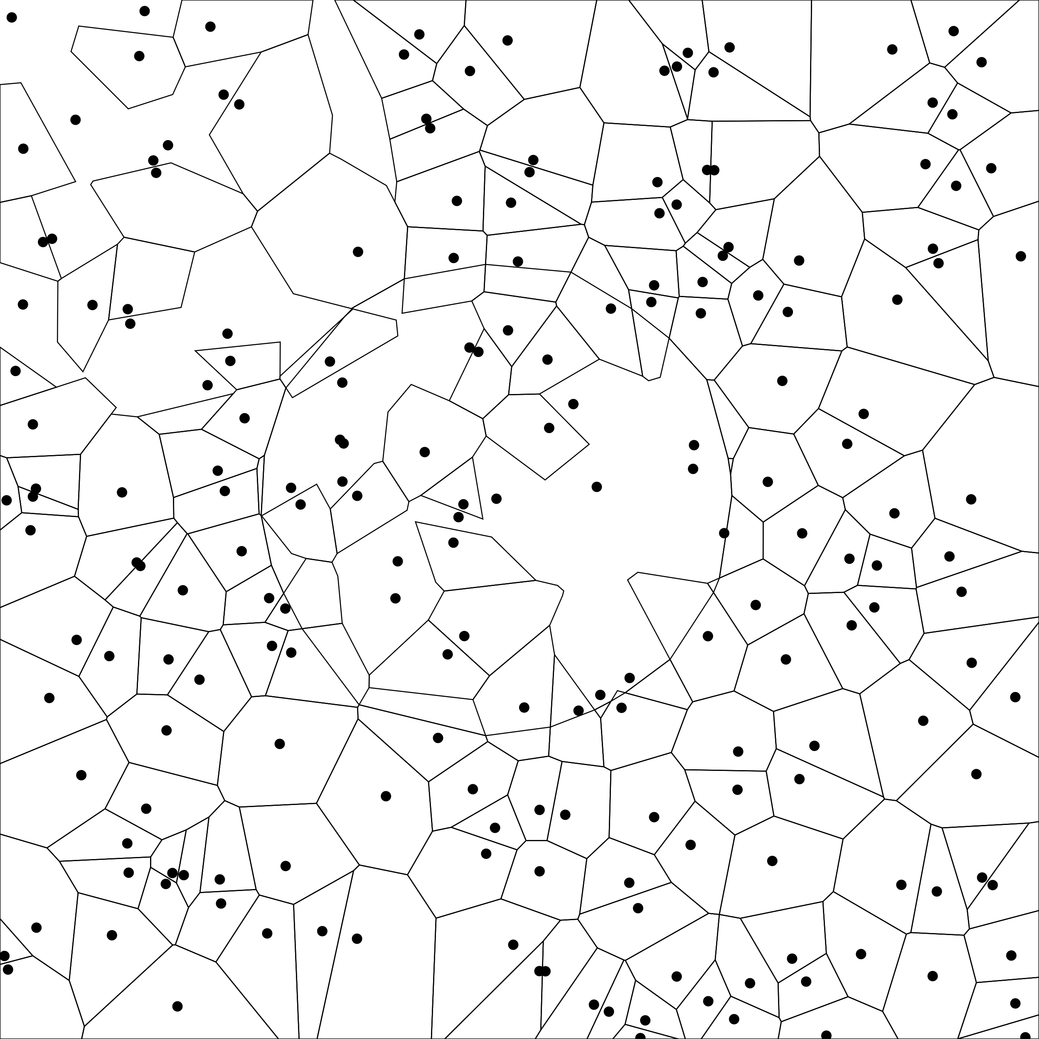 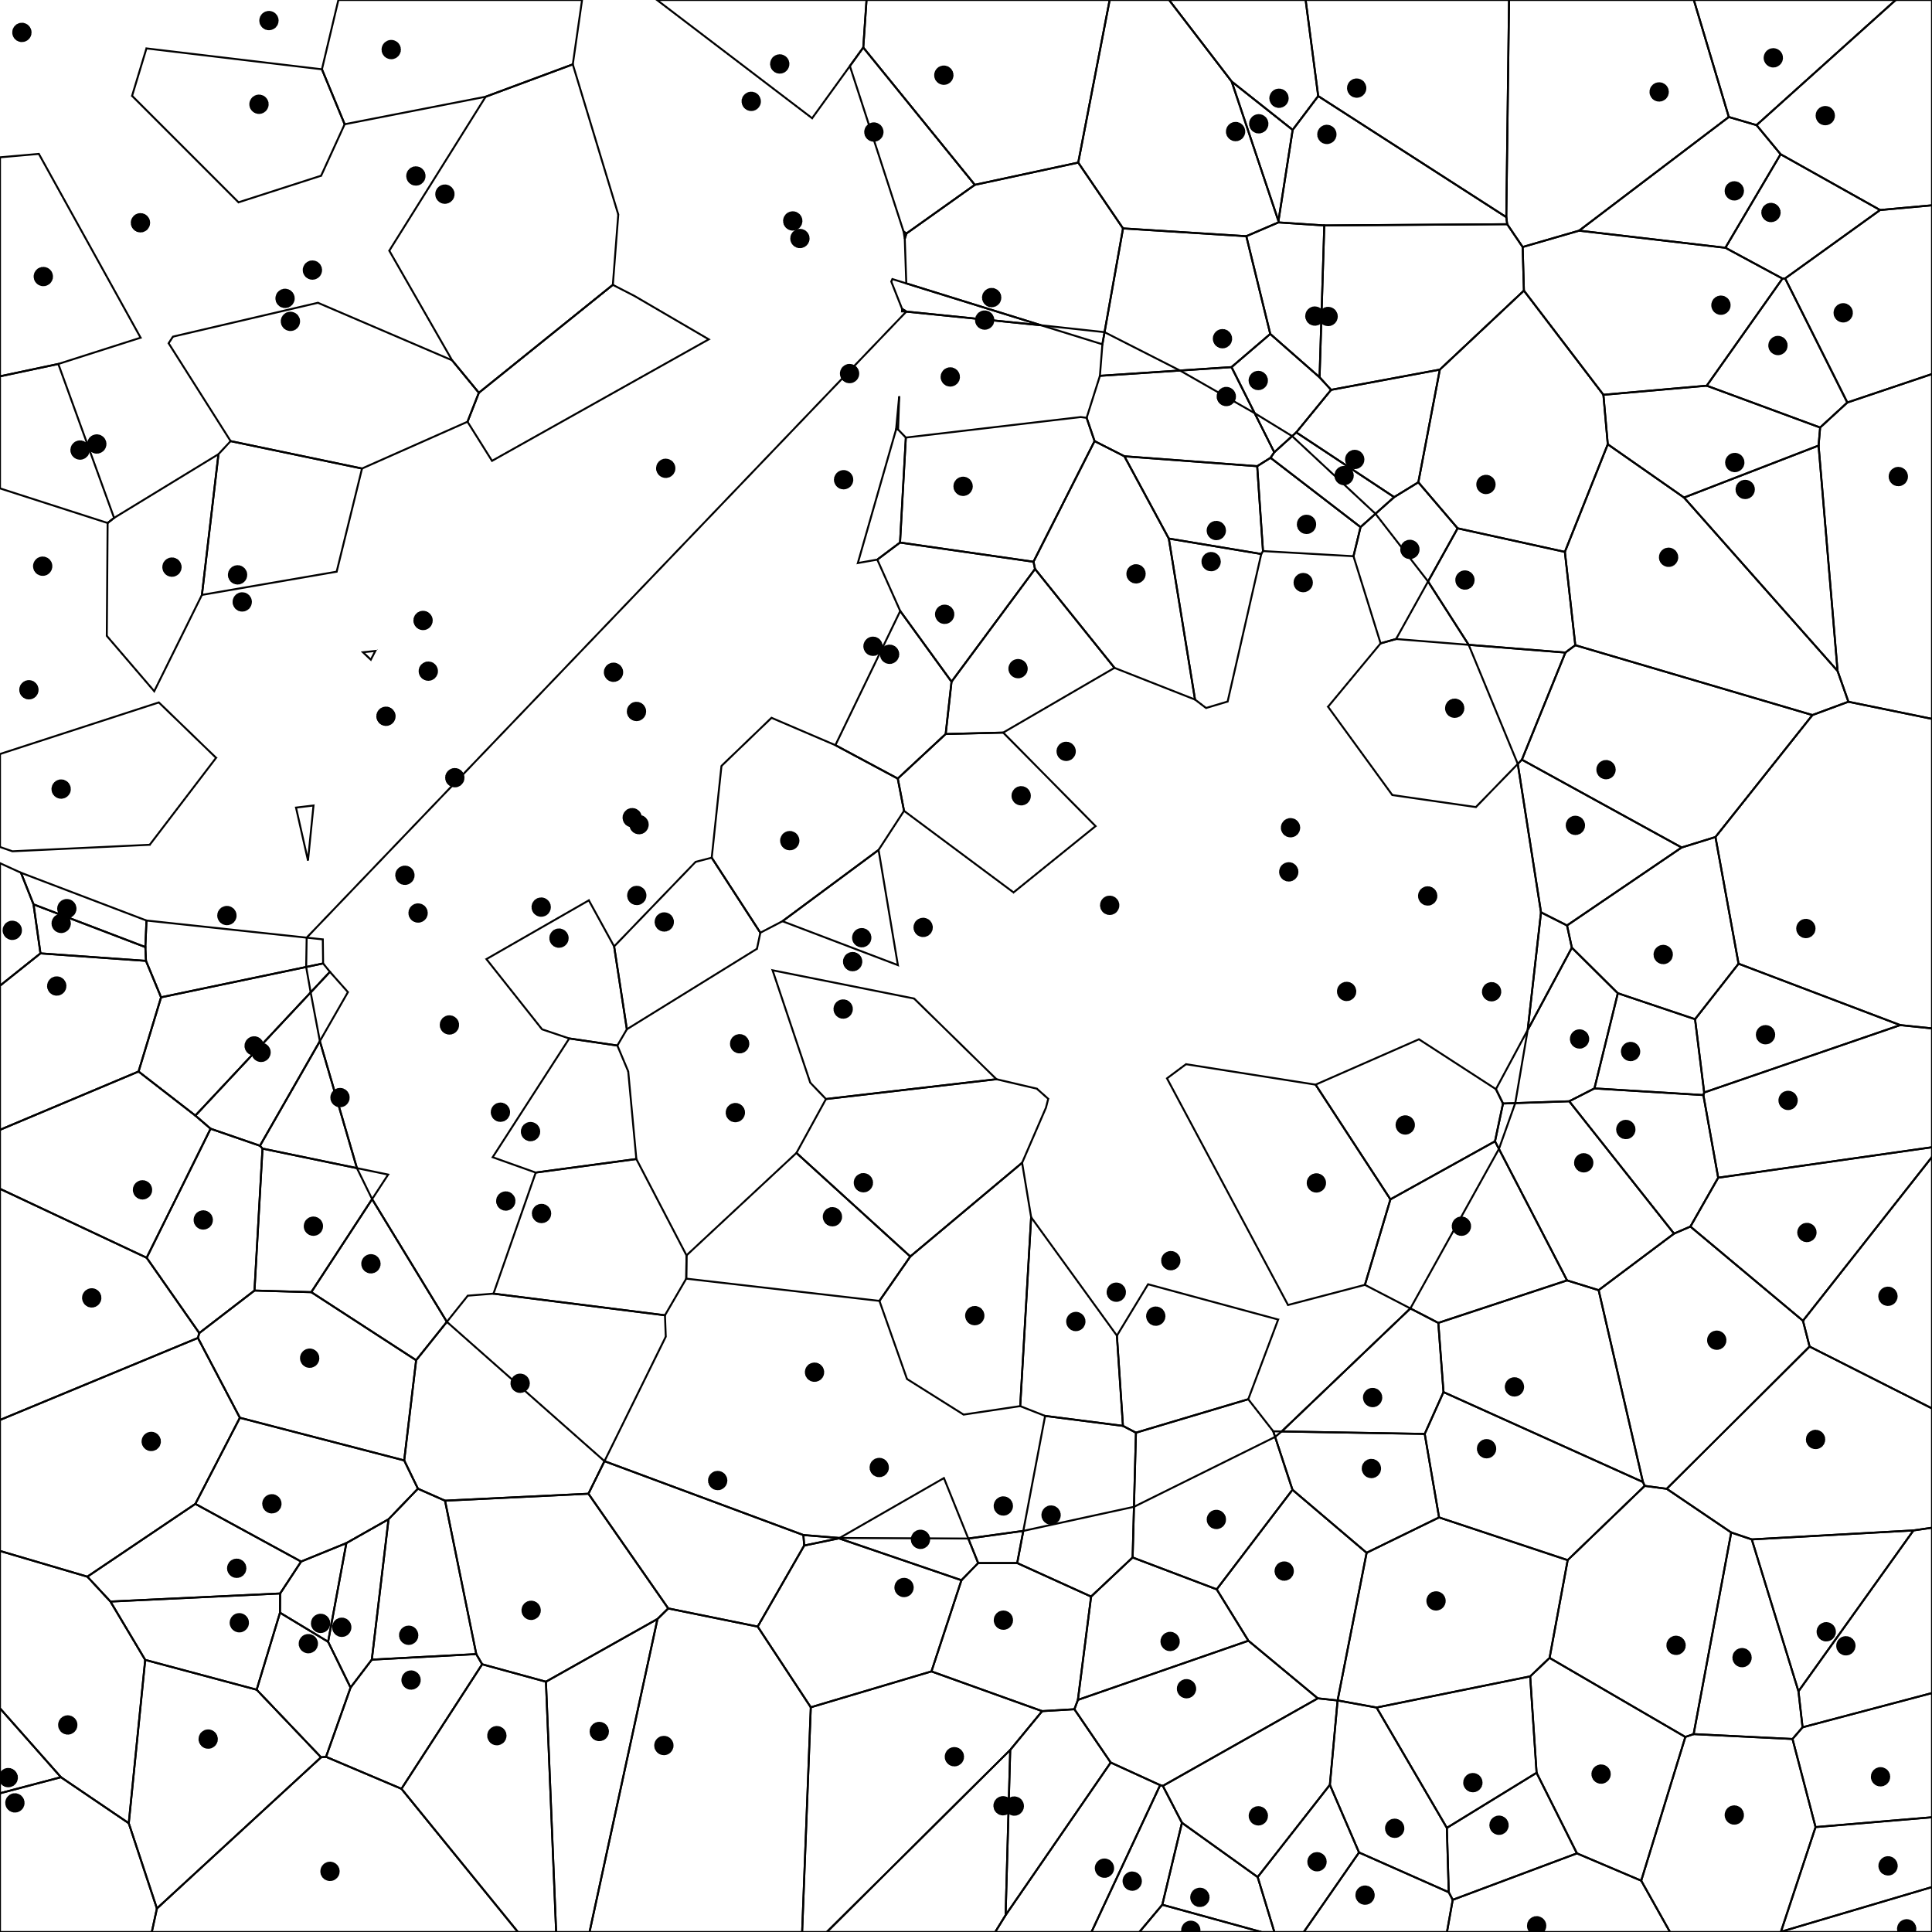

w_i = 0.2 and w_105 = 0.23 w_i = 0.2 and w_105 = 0.25 w_i = 0.2 and w_105 = 0.5